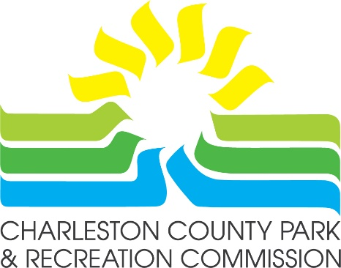

Park and Recreation Small Project Grant Program Information

The mission of the Charleston County Park and Recreation Commission (CCPRC) is to improve the quality of life in Charleston County by offering a diverse system of park facilities, programs and services. Each year CCPRC receives funding from the South Carolina Department of Parks, Recreation and Tourism’s Park and Recreation Development fund (PARD). The funding is to be used for permanent improvements to public park and recreation facilities. CCPRC would like to solicit your proposals for ways to provide these improvements in your community via our Small Project Grant Program.

Eligibility
Proposals are accepted from non-profit groups such as 501(c)(3) organizations, community centers, governmental entities, and recognized houses of worship located in and serving residents of Charleston County. Acceptable proposals should be for permanent improvements to a facility that would be open to the public for general use.
Proposals should be for modest outdoor or open-air elements. Proposals should not be made to supplement funding for capital projects as funds would not be sufficient or appropriate for capital projects that would involve the construction of buildings, gyms, pools, etc.

Requirements
Interested organizations must complete the application explaining the nature of the proposal. Application narrative must include: (1) how the proposal will support the stated mission of CCPRC (above); (2) how the public will benefit from the proposed project, and; (3) how the local organization will provide long-term support for the project. Applicant will be required to indemnify CCPRC. Applicant will need to provide on-going maintenance for the improvements. And lastly, applicant will also be required to maintain liability insurance and provide proof of insurance with their application.

Schedule
Proposals are accepted from May through September. Application review will begin on October 1, and applicants will be notified of their status by November 1. Please note that all funding is contingent upon the CCPRC receiving PARD funds and budgetary approval.

Submit completed form via mail or email to:
Phil Macchia
Chief Operating Officer
861 Riverland Drive, Charleston, SC 29412
Email: Phil.Macchia@ccprc.com
Small Project Grant Program Application Form
Interested organizations must complete the application and a one-page narrative explaining the nature of the proposal. The narrative letter must include: (1) how the proposal will support the stated mission of CCPRC (above); (2) how the public will benefit from the proposed project, and; (3) how the local organization will provide long-term support for the project. Applicant will be required to indemnify CCPRC, maintain liability insurance and provide on-going maintenance for the improvements.

*Required field.
Organization Name:*
Year Founded:*
Mailing Address:*
Telephone Number:*
Federal EIN Number (Tax ID):*
Email Address*
Website Address (if applicable):
Executive Director (if applicable):
Executive Director's Email:
Project Location:*
Project Location Address:*
Contact Person (for this proposal):*
Contact Person's Title*
Contact Person's Email:*
Contact Person's Phone Number:*
Applicant Organization's Mission Statement:*

Please give a brief history of your organization:*

Proposal Narrative*

Please describe your project and how you would like funding to be used. Remember to include (1) how the proposal will support the stated mission of CCPRC; (2) how the public will benefit from the proposed project, and; (3) how the local organization will provide long-term support (maintenance, upkeep, liability insurance, etc.) for the project. Proposal narratives may be hand-written in the space provided below or can be attached as a separate document to your submission.

